Database **View** as a Source

In **SSMS** create a view

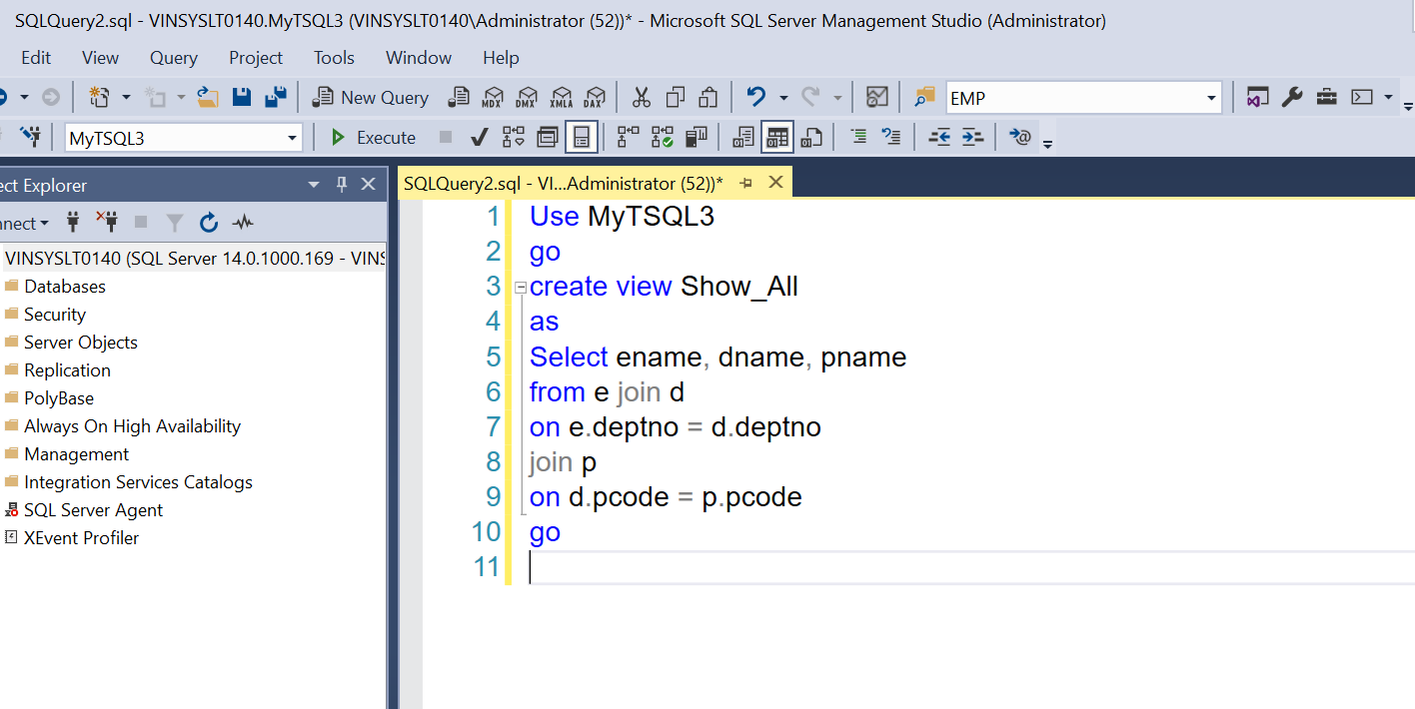

The View SQL statement is as below:

There are 3 tables e, d and p.

Use MyTSQL3

go

create view Show_All

as

Select ename, dname, pname

from e join d

on e.deptno = d.deptno

join p

on d.pcode = p.pcode

go

In PBI: Write SQL statement based on the above view!!!

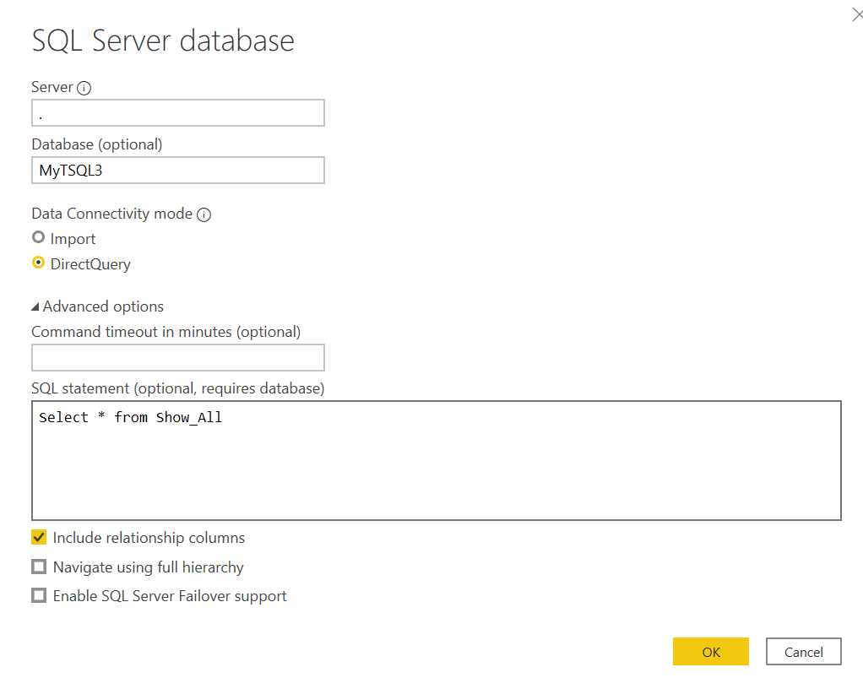

The table name will be **Query<Number>**